Number Sets
# Source: AI Source: Provided by: [Data Path: Persons Table -> ID Column: 1, Name_En Column: Motasem Essam] -> From: [ChatGPT] on [7/15/2026]
Number Sets are collections of numbers grouped according to shared mathematical properties. Each number set is defined by specific rules that determine which numbers belong to it.
Number sets form the foundation of arithmetic, algebra, geometry, calculus, number theory, statistics, computer science, engineering, and nearly every branch of mathematics.

Definition
# Source: AI Source: Provided by: [Data Path: Persons Table -> ID Column: 1, Name_En Column: Motasem Essam] -> From: [ChatGPT] on [7/15/2026]
A Number Set is a collection of numbers that satisfy a common mathematical property or definition.
Number sets are usually represented using set notation and standard mathematical symbols.

Major Number Sets
# Source: AI Source: Provided by: [Data Path: Persons Table -> ID Column: 1, Name_En Column: Motasem Essam] -> From: [ChatGPT] on [7/15/2026]
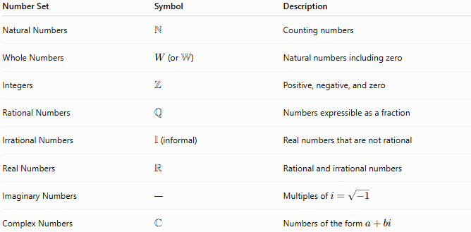
Number Set | Symbol | Description
Natural Numbers | $$N$$ | Counting numbers
Whole Numbers | $W$(or $W$) | Natural numbers including zero
Integers | $$Z$$ | Positive, negative, and zero
Rational Numbers | $$Q$$ | Numbers expressible as a fraction
Irrational Numbers | $I$(informal) | Real numbers that are not rational
Real Numbers | $$R$$ | Rational and irrational numbers
Imaginary Numbers | — | Multiples of $i=\sqrt{-1}$
Complex Numbers | $$C$$ | Numbers of the form $a+bi$
Note: The symbol $I$for irrational numbers is commonly used in education but is not a universally standardized symbol. Mathematically, irrational numbers are often defined as $R∖Q$(the real numbers excluding the rational numbers).

Hierarchy of Number Sets
# Source: AI Source: Provided by: [Data Path: Persons Table -> ID Column: 1, Name_En Column: Motasem Essam] -> From: [ChatGPT] on [7/15/2026]
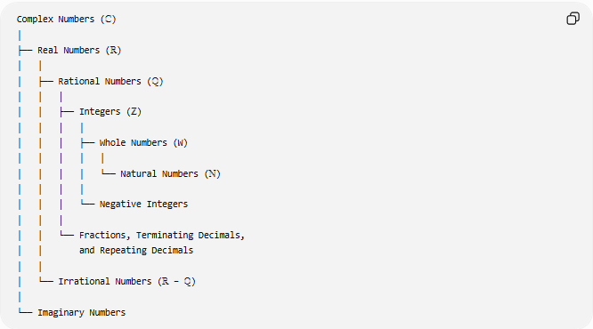
Complex Numbers (ℂ)
│
├── Real Numbers (ℝ)
│ │
│ ├── Rational Numbers (ℚ)
│ │ │
│ │ ├── Integers (ℤ)
│ │ │ │
│ │ │ ├── Whole Numbers (W)
│ │ │ │ │
│ │ │ │ └── Natural Numbers (ℕ)
│ │ │ │
│ │ │ └── Negative Integers
│ │ │
│ │ └── Fractions, Terminating Decimals,
│ │ and Repeating Decimals
│ │
│ └── Irrational Numbers (ℝ − ℚ)
│
└── Imaginary Numbers

1. Natural Numbers
# Source: AI Source: Provided by: [Data Path: Persons Table -> ID Column: 1, Name_En Column: Motasem Essam] -> From: [ChatGPT] on [7/15/2026]
Symbol:
$$N$$
Set:
$$\boxed{N=\{1,2,3,4,…\}}$$
Used for counting.

2. Whole Numbers
# Source: AI Source: Provided by: [Data Path: Persons Table -> ID Column: 1, Name_En Column: Motasem Essam] -> From: [ChatGPT] on [7/15/2026]
Symbol:
$$W$$
Set:
$$\boxed{W=\{0,1,2,3,…\}}$$

3. Integers
# Source: AI Source: Provided by: [Data Path: Persons Table -> ID Column: 1, Name_En Column: Motasem Essam] -> From: [ChatGPT] on [7/15/2026]
Symbol:
$$Z$$
Set:
$$\boxed{Z=\{…,-3,-2,-1,0,1,2,3,…\}}$$

4. Rational Numbers
# Source: AI Source: Provided by: [Data Path: Persons Table -> ID Column: 1, Name_En Column: Motasem Essam] -> From: [ChatGPT] on [7/15/2026]
Symbol:
$$Q$$
Definition:
$$\boxed{Q=\left\{\frac{a}{b}:a,b∈Z,b≠0\right\}}$$
Examples:
$$\frac{1}{2}, -\frac{3}{5}, 5, 0.25, 0.777…$$

5. Irrational Numbers
# Source: AI Source: Provided by: [Data Path: Persons Table -> ID Column: 1, Name_En Column: Motasem Essam] -> From: [ChatGPT] on [7/15/2026]
Definition:
$$\boxed{R-Q}$$
Examples:
$$π, e, \sqrt{2}, \sqrt{5}$$
Properties:
- Infinite decimals
- Non-terminating
- Non-repeating

6. Real Numbers
# Source: AI Source: Provided by: [Data Path: Persons Table -> ID Column: 1, Name_En Column: Motasem Essam] -> From: [ChatGPT] on [7/15/2026]
Symbol:
$$R$$
Definition:
$$\boxed{R=Q∪(R-Q)}$$
Examples:
All numbers on the number line.

7. Imaginary Numbers
# Source: AI Source: Provided by: [Data Path: Persons Table -> ID Column: 1, Name_En Column: Motasem Essam] -> From: [ChatGPT] on [7/15/2026]
Definition:
Numbers involving
$$i=\sqrt{-1}$$
Examples:
$$i, 2i, -5i$$

8. Complex Numbers
# Source: AI Source: Provided by: [Data Path: Persons Table -> ID Column: 1, Name_En Column: Motasem Essam] -> From: [ChatGPT] on [7/15/2026]
Symbol:
$$C$$
Definition:
$$\boxed{C=\{a+bi:a,b∈R\}}$$
Examples:
$$3+2i, 7-i, -5+4i$$

Set Inclusion
# Source: AI Source: Provided by: [Data Path: Persons Table -> ID Column: 1, Name_En Column: Motasem Essam] -> From: [ChatGPT] on [7/15/2026]
The relationships between the main number sets are
$$\boxed{N⊂W⊂Z⊂Q⊂R⊂C}$$
This means every natural number is also a whole number, every whole number is an integer, and so on.

Examples of Membership
# Source: AI Source: Provided by: [Data Path: Persons Table -> ID Column: 1, Name_En Column: Motasem Essam] -> From: [ChatGPT] on [7/15/2026]
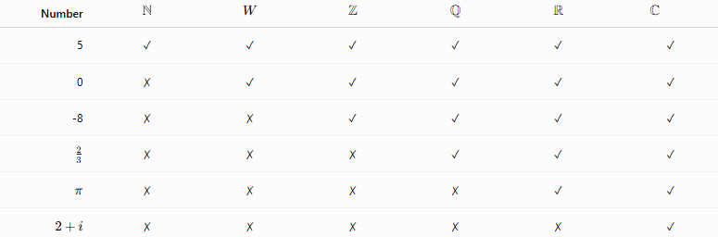
Number | $$N$$ | $$W$$ | $$Z$$ | $$Q$$ | $$R$$ | $$C$$
5 | ✓ | ✓ | ✓ | ✓ | ✓ | ✓
0 | ✗ | ✓ | ✓ | ✓ | ✓ | ✓
-8 | ✗ | ✗ | ✓ | ✓ | ✓ | ✓
$$\frac{2}{3}$$ | ✗ | ✗ | ✗ | ✓ | ✓ | ✓
$$π$$ | ✗ | ✗ | ✗ | ✗ | ✓ | ✓
$$2+i$$ | ✗ | ✗ | ✗ | ✗ | ✗ | ✓

Set Operations
# Source: AI Source: Provided by: [Data Path: Persons Table -> ID Column: 1, Name_En Column: Motasem Essam] -> From: [ChatGPT] on [7/15/2026]
Number sets can be combined using standard set operations.

Union
# Source: AI Source: Provided by: [Data Path: Persons Table -> ID Column: 1, Name_En Column: Motasem Essam] -> From: [ChatGPT] on [7/15/2026]
$$A∪B$$
Elements belonging to either set.
Example:
$$R=Q∪(R-Q)$$

Intersection
# Source: AI Source: Provided by: [Data Path: Persons Table -> ID Column: 1, Name_En Column: Motasem Essam] -> From: [ChatGPT] on [7/15/2026]
$$A∩B$$
Elements common to both sets.
Example:
$$Z=Q∩Z$$

Difference
# Source: AI Source: Provided by: [Data Path: Persons Table -> ID Column: 1, Name_En Column: Motasem Essam] -> From: [ChatGPT] on [7/15/2026]
$$A-B$$
Elements in $A$but not in $B$.
Example:
$$R-Q$$
is the set of irrational numbers.

Subset
# Source: AI Source: Provided by: [Data Path: Persons Table -> ID Column: 1, Name_En Column: Motasem Essam] -> From: [ChatGPT] on [7/15/2026]
$$A⊂B$$
Every element of $A$belongs to $B$.
Example:
$$Z⊂Q$$

Applications
# Source: AI Source: Provided by: [Data Path: Persons Table -> ID Column: 1, Name_En Column: Motasem Essam] -> From: [ChatGPT] on [7/15/2026]
Number sets are used in:
- Arithmetic
- Algebra
- Geometry
- Calculus
- Number Theory
- Statistics
- Computer Science
- Engineering
- Physics
- Economics

Real-Life Applications
# Source: AI Source: Provided by: [Data Path: Persons Table -> ID Column: 1, Name_En Column: Motasem Essam] -> From: [ChatGPT] on [7/15/2026]
Number sets are used in:
- Financial calculations
- Engineering design
- Scientific simulations
- Computer programming
- Artificial intelligence
- Cryptography
- Signal processing
- Data analysis
- Robotics
- Physics

Common Mistakes
# Source: AI Source: Provided by: [Data Path: Persons Table -> ID Column: 1, Name_En Column: Motasem Essam] -> From: [ChatGPT] on [7/15/2026]
- Confusing number sets with number systems.
- Assuming every decimal is irrational.
- Thinking irrational numbers are not real numbers.
- Forgetting that every real number is also a complex number.
- Confusing set membership ($∈$) with subset ($⊂$).

Key Points
# Source: AI Source: Provided by: [Data Path: Persons Table -> ID Column: 1, Name_En Column: Motasem Essam] -> From: [ChatGPT] on [7/15/2026]
- Number sets organize numbers according to shared properties.
- Each larger set extends the previous one.
- Number sets are represented using standard symbols such as $N$, $Z$, and $R$.
- Set notation provides a precise way to describe collections of numbers.
- Number sets are fundamental to all areas of mathematics.

Number Sets vs. Number Types
# Source: AI Source: Provided by: [Data Path: Persons Table -> ID Column: 1, Name_En Column: Motasem Essam] -> From: [ChatGPT] on [7/15/2026]
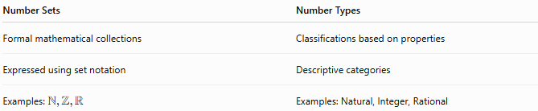
Number Sets | Number Types
Formal mathematical collections | Classifications based on properties
Expressed using set notation | Descriptive categories
Examples: $N,Z,R$ | Examples: Natural, Integer, Rational

Number Sets vs. Number Systems
# Source: AI Source: Provided by: [Data Path: Persons Table -> ID Column: 1, Name_En Column: Motasem Essam] -> From: [ChatGPT] on [7/15/2026]
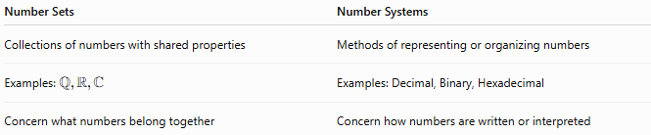
Number Sets | Number Systems
Collections of numbers with shared properties | Methods of representing or organizing numbers
Examples: $Q,R,C$ | Examples: Decimal, Binary, Hexadecimal
Concern what numbers belong together | Concern how numbers are written or interpreted

Conclusion
# Source: AI Source: Provided by: [Data Path: Persons Table -> ID Column: 1, Name_En Column: Motasem Essam] -> From: [ChatGPT] on [7/15/2026]
Number Sets are formal mathematical collections of numbers that share common properties. The principal sets—natural numbers, whole numbers, integers, rational numbers, irrational numbers, real numbers, and complex numbers—form a hierarchical structure in which each larger set extends the previous one. Understanding number sets provides the foundation for set theory, algebra, calculus, and virtually every branch of modern mathematics and its applications in science, engineering, economics, and computer

